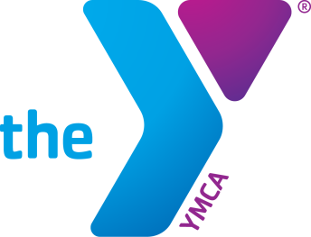
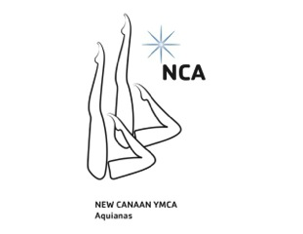
2017 13/15, JR & SR
Association Championship
(Connecticut & Metropolitan Associations)
January 28-29th 2017 – New Canaan, CT

SPONSORED BY New Canaan YMCA Aquianas

SANCTIONED BY United States Synchronized Swimming

FACILITY: New Canaan YMCA
564 South Avenue, New Canaan CT, 06840

PARKING Use the staff parking lot located to the right of the building

EVENTS 13/15 – Duet, Solo, Team, Combo, and Figures
Jr – Duet, Solo, Team, Combo, and Figures
Sr – Duet, Solo, Team, Combo, and Figures

FIGURES: 13/15 Age Group
423 Ariana 2.8
301e Barracuda Spinning 360 2.2

Junior
308 Barracuda Airborne Split 2.8
355g Porpoise Twist Spin 2.8

TENTATIVE SCHEDULE
Saturday, January 28th

5pm doors open
515-530pm coaches meeting
530-6pm lap swimming (diving well)
6-630pm figure warmup (diving well)
640-715pm 13-15 figures
715-8pm Jr figures

Sunday, January 29th

6am doors open
615-630am coaches meeting
630-7am lap swimming
7-720am combo warmup
730-745am combo competition (2)
745-8am duet warmup
8-850am duet competition (9)
9-915am solo warmup
915-10am solo competition (8)
10-1020am team warmup
1030-11am team competition (5)

