2016 Region A
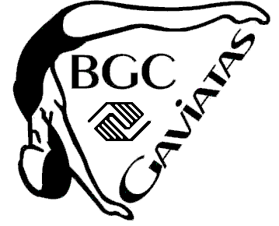
Intermediate and Age Group Regional Championships

Date: May 14 and May 15, 2016

Location: Owego Free Academy High School
1 Sheldon Guile Blvd, Owego, NY

Events: 10/UI, 11/12I, 13/OI solo, duet, trio, team, figures
12/UAG, 13-15AG, 16-17AG, 18-19AG solo, duet, team, combo, figures

Qualification: Swimmers placing 1-3 in each age group, in each event, in each association intermediate and age group championship.

Figures:
- Intermediate and 12/U Figures
101 Ballet Leg 1.6
301 Barracuda 2.0
- 13/15 AG Figures
423 Ariana 2.8
301e Barracuda Spinning 360 2.2
- 16-19 Figures (Compulsory only)
308 Barracuda Airborne Split 2.8
355g Porpoise Twist Spin 2.8
Optional figure groups will be drawn 18-72 hours before the meet begin

Tentative Schedule (will be adjusted after all entries are received)

Saturday May 14
Doors open at 8:00am Intermediate and 12 Under age groups
Intermediate and 12/UAG figures
Intermediate trio, Intermediate and 12/UAG duet, Intermediate and 12/UAG solo, Intermediate and 12/UAG team,
4 pm 13/15, 16/17, and 18/19 Age groups figures
13/15AG figures,
16/19AG figures

Sunday May 15 Doors open at 9:00am 13/15, 16/17, and 18/19 routines
13/15, 16/17, 18/19 solo
13/15, 16/19 combo
13/15, 16/17, 18/19 duet
13/15, 16/17, 18/19 team
Anticipated end time - 2 pm

