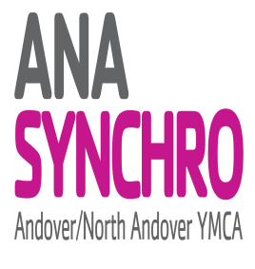
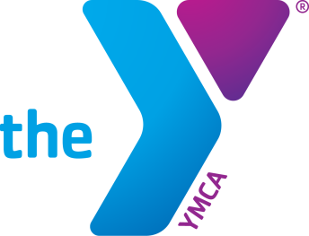
2020 East Zone 13-15 Championships
February 8-9, 2020 Andover, MA

SPONSORED BY ANA YMCA Synchro

SANCTIONED BY United States Synchronized Swimming

RULES TO GOVERN: 2020 Official USSS Rules
2020 East Zone Synchronized Swimming Rules

FACILITY: Andover/North Andover YMCA
165 Haverhill St.
Andover, MA 01810

POOL SPECS: Length: 25 yards
Width: 6 Lanes
Depth: 10 ft. to 7 ft. (midpoint) to 4 ft.
Distance of water from deck level: 0 ft.
Type of Pool; Entry: Deep end, spectator seating on deck

ELIGIBILITY 1. Must be a registered USSS athlete.
2. Open to ALL athletes between the ages of 13-15

EVENTS Solo, Duet, Mixed Duets, Team, Combo and Figures
(Note: Athletes can compete in Duet, or Mixed Duet, but not both)

TENTATIVE SCHEDULE
Detailed tentative schedule will be produced based on the pre-meet entries received after pre-meet entry deadline.

Saturday, February 8th Order of Events: Figures (everyone does figures), Preliminaries (Duet, Solo, Team)
Sunday, February 9th Order of Events: Finals (Mixed Duet, Duet, Solo, Team, Combo), Awards

