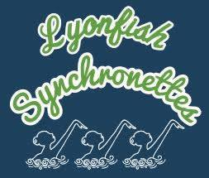
East Zone Invitational
March 13-15, 2020

SPONSORED BY Cambridge Synchro
Attleboro YMCA Lyonfish Synchronettes
and Wheaton College

FACILITY Hass Athletic Center – Balfour Natatorium, Wheaton College
26 East Main Street, Norton, MA 02766

POOL SPECS Length: 40 meters with movable bulkhead
Width: 8 lanes
Depth: Entry 13ft, Midpoint 9ft, End of competition area 8ft
Entry: Deep end, starting blocks and two diving boards
Deck space: Entry end 14’8”, Opp. End 4’ Bulkhead, Side 1: 5’2”, Side 2: 9’9”
Spectator seating: Balcony area seating 350 people

ELIGIBILITY Open to all Intermediates, 12&Under Age Group, 13-15 Age Group, 16&Over Age Group with exceptions of over qualifications listed below.

Over qualifications: Any swimmer who participated in the East Zone 13-15 AG Championships and/or the East Zone Junior/Senior Championships is overqualified for Invitational in that event only.

EVENTS Intermediate: Solo, Duet, Mixed Duet, Trio, Team, Combo, Figures
12&Under Age Group: Solo, Duet, Mixed Duet, Team, Figures
13-15 Age Group: Solo, Duet, Mixed Duet, Team, Combo, Figures
16&Over Open: Free - Solo, Duet, Mixed Duet, Team, Combo

*Detailed schedule will be based on pre-meet entries. The order and days of events may change.
Friday March 15: Intermediate solos

Saturday, March 16: Intermediate and 12&Under Figures, Intermediate Duets, Mixed Duets, Trios, Teams and Combos followed by awards.

Sunday, March 17: 13-15 AG Figures, AG Solos, Duets, Mixed Duets, Teams and Combos followed by Awards.

